The Herakles knot, sometimes called the reef knot, is one of the most iconic and replicated designs of the Hellenistic period. The three versions of this knots were used in sculpture, painting, and pottery, however, they were most frequent in jewelry. Although there are many artifacts showing this Greek design, many scholars debate the methods used to create it, as well as its purpose and appeal during the Hellenistic period. Despite this controversy, the Herakles knot was probably one of the most popular designs of this period and versions of it remain prominent today.
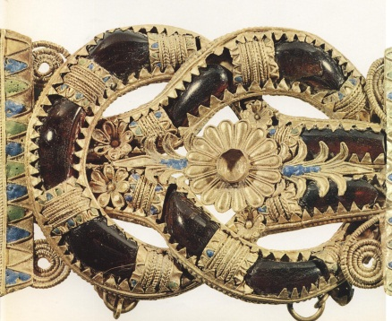
Image 1: Herakles Knot Diadem
The Herakles knot (above) is one of the most common images found in Hellenistic jewelry consisting of two interlocking loops. After construction, the two loops are usually decorated with jewels or other metal embellishments.
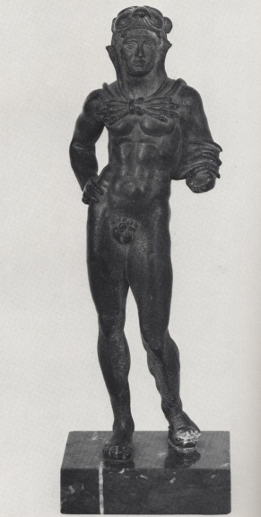
Image 2: Herakles from 2nd Century AD
The myth of Herakles (above) served as the inspiration for the design of the Herakles knot. Herakles was the illegitimate son of Zeus and a mortal woman whom Zeus had an affair with. Hera, Zeus’s wife, hated Herakles because he proved Zeus’s unfaithfulness and thus, she spent a great deal of time plotting against him. Herakles was raised as mortal son of Alcmene, although he exhibited heroic strength and power throughout his life. After killing his family because he was driven crazy by Hera, Herakles visited the Oracle of Delphi who instructed him to complete ten tasks set out by King Eurystheus. If he completed these tasks he was to be granted immortality. After completing the ten, he was accusing of cheating and assigned two more, thus creating the twelve labors of Herakles. Frequently, the Herakles knot is surrounded by small domes which represent this challenge. Herakles died after his fourth wife, Deianeria, gave him a poisonous blood soaked cape, which she thought would excite the love of her husband. The poisonous cape put Herakles in such great pain that he killed himself by burning to death. His immortal half rose to Olympus as he died.

Herbert Hoffman, Greek Gold: Jewelry from the age of Alexander (New York City: The Brooklyn Museum, 1965), 31
Graham Hughes, The Art of Jewelry (New York: The Viking Press, 1972), 31
Hoffman, 30.
(Image Source: Hughes, Graham. The Art of Jewelry. New York City: Viking Press, 1972. p. 30).
Hoffman, 30. Jack Ogden, Jewellery of the Ancient World (London: Trefiol Books, Ltd, 1982), 90. Hughes, 32.
Hughes, 31. Ogden, 90. Hoffman, 30.
(Image Source: Uhlenbrock, Jaimee-Pugliese, & Galinsky, Karl. Herakles: Passage of the Hero Through 1000 Years of Classical Art. New York City: Edith C. Blum Art Institute, Bard College, 1986. p. 32).
W.K.C. Guthrie. The Greeks and their Gods (USA: the Beacon Press, 1967), 237. Nigel Jonathan Spivey, Songs on bronze : the Greek myths made real (New York : Farrar, Straus and Giroux, 2005), 42. Jaimee Pugliese Uhlenbrock, Karl Galinsky, Herakles: Passage of the Hero Through 1000 Years of Classical Art (NYC: Edith C. Blum Art Institute, Bard College, 1986), 1.
Guthrie, 236. Spivey, 42. Uhlenbrock, 1.
Guthrie, 237. Spivey, 47. Uhlenbrock, 2.
Guthrie, 238. Spivey, 57. Uhlenbrock, 2.
Guthrie, 242. Spivey, 57. Uhlenbrock, 4.
Guthrie, 111. Spivey, 59. Uhlenbrock, 4.
. Hoffman, 39.
Guthrie, 98 Uhlenbrock, 5. Spivey,65.
Herakles, Mlahanas Institute, 2008, http://www.mlahanas.de/Greeks/Mythology/Heracles.html , 25 March 2009. Uhlenbrock, 5. Spivey,65.
, Mlahanas Institute, 25 March 2009. Uhlenbrock, 5. Spivey,43.

